14.65: Neglecting the buoyancy of the air, the weight in air is

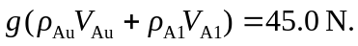

and the buoyant force when suspended in water is

These are two equations in the two unknowns 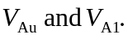 Multiplying the second by 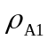 and the first by 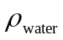and subtracting to eliminate the 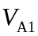term gives

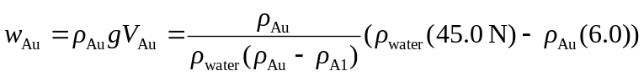
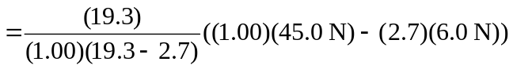
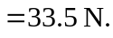
Note that in the numerical determination of 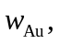specific gravities were used instead of densities.

